RV COLLEGE OF ENGINEERING®, BENGALURU-560059

(Autonomous Institution Affiliated to VTU, Belagavi)

**DEPARTMENT OF COMPUTER SCIENCE AND ENGINEERING**



##### Sketch-Photo synthesis based criminal record search

##### Mini - Project Report

###### *Submitted by*

**Pratheeksha P 1RV17CS112**

**Prerana Shenoy SP 1RV17CS114**

***in partial fulfillment for the requirement of 5th Semester***

***DBMS Laboratory Mini Project (16CS52)***

**Under the Guidance of**

**Prof. Pratibha D,**

**Asst. Professor, Department of Computer Science and Engineering,**

**R.V. College of Engineering,**

**Bengaluru**

**Academic Year 2019 - 2020**

**RV COLLEGE OF ENGINEERING®, BENGALURU - 560059**

**(Autonomous Institution Affiliated to VTU, Belagavi)**

**DEPARTMENT OF COMPUTER SCIENCE AND ENGINEERING**



**CERTIFICATE**

Certified that the project work titled **‘Sketch-photo synthesis based criminal record search’** is carried out by **Pratheeksha P (1RV17CS112) and Prerana Shenoy SP (1RV17CS108),** who are bonafide students of RV College of Engineering®, Bengaluru, in partial fulfillment of the curriculum requirement of 5th Semester Database Design Laboratory Mini Project during the academic year **2019-2020**. It is certified that all corrections/suggestions indicated for the internal Assessment have been incorporated in the report deposited in the departmental library. The report has been approved as it satisfies the academic requirements in all respect laboratory mini-project work prescribed by the institution.

**Signature of Faculty In-charge** **Head of the Department**

**Dept. of CSE, RVCE**

**External Examination**

**Name of Examiners Signature with date**

**1**

**2**

**ACKNOWLEDGEMENT**

Any achievement, be it scholastic or otherwise does not depend solely on the individual efforts but on the guidance, encouragement and cooperation of intellectuals, elders and friends. A number of personalities, in their own capacities have helped me in carrying out this project work. I would like to take this opportunity to thank them all.

I deeply express my sincere gratitude to my guide **Prof. Pratibha D, Asst. Professor,** Department of CSE, RVCE, Bengaluru,for her able guidance, regular source of encouragement and assistance throughout this project

I would like to thank **Dr. Ramakanth Kumar P**, Head of Department, Computer Science & Engineering, R.V.C.E, Bengaluru, for his valuable suggestions and expert advice.

First and foremost, I would like to thank **Dr. Subramanya. K. N**, Principal, R.V.C.E, Bengaluru, for his moral support towards completing my project work.

I thank my Parents, and all the Faculty members of Department of Computer Science & Engineering for their constant support and encouragement.

Last, but not the least, I would like to thank my peers and friends who provided me with valuable suggestions to improve my project.

**Abstract**

This project is a criminal record search developed to provide a faster identification of suspects for criminal investigation. Existing systems use sketches drawn by an artist based on the eye-witness description. They are posted in public places and media hoping that someone will recognize the suspect and provide information’s leading to arrest. This method is very useful and many criminals are captured by this way. But this method of identifying is slow and tedious and it does not using the available large resource of law enforcement agency. The proposed system aids law enforcement agencies in quick retrieval of personal details and criminal history of the potential suspect.

The system consists of two components – the application and the external databases. The user (investigation team) uploads the sketch of the suspect. The input from the user is handled by the application component. The application synthesizes a realistic photo which is used to identify the suspect. SQL and NoSQL databases are integrated with the application to store personal details and criminal records of the offenders.

**Table of Contents**

**Chapter 1**

Introduction 7

1.1 Objectives 7

1.2 Scope 7

**Chapter** **2**

Software Requirement Specification 8

2.1 Hardware Requirements 8

2.2 Software Requirements 8

2.3 Functional Requirements 9

**Chapter 3**

Entity Relationship Diagram 11

**Chapter 4**

Detailed Design 12

4.1 DFD Level 0 12

4.2 DFD Level 1 13

4.3 DFD Level 2 of sketch-photo conversion 14

4.4 DFD Level 2 of criminal record search 15

**Chapter 5**

Relational Schema and Normalization 16

**Chapter 6**

Integrating NoSQL to SQL Database 21

**Chapter 7**

Conclusion  22 References  23

Appendix : Screenshots with descriptions 24

**GLOSSARY**

DFD : Data Flow Diagram

ER : Entity Relationship

SRS : Software Requirement Specification

GAN : Generative adversarial networks

**Chapter 1**

# Introduction

One of the important clues in solving crimes and apprehending criminals is matching facial composites with mug shots based on eyewitness memory. Sketches have been the go-to mechanism for law enforcement agencies when the identity of a crime suspect or murder victim is not known. But this method of identifying is slow and tedious and it does not make use of the available large resource of law enforcement agency.

**1.1 Objectives**

In criminal investigations, photos of suspects are usually hard to acquire and it is known that commercial software or experienced artists are sought to generate sketches of a suspect based on the description of eyewitness.The purpose of criminal record search by sketch-photo synthesis is to aid law enforcement in automatic retrieval of photos and details of potential suspects. The main objective of the system is to generate realistic images of suspects despite the inaccuracies in hand-drawn sketches and provide precise matching of these images in the mug shot database.

**1.2 Scope**

The scope of this product is to assist law enforcement agencies in the process of identification of suspects by sketch-photo synthesis which speeds up the criminal investigation. This results in improvement in the criminal record search and makes it possible for large number of cases to be solved in a short amount of time. This can be used by the Police for various types of cases. The proposed work includes a few of those cases.

**Chapter** **2**

# Software Requirement Specification

The proposed system aims to identify the potential suspects and therefore, must be efficient enough to avoid misleads which may delay the investigation process. There are hardware and software specifications which must be met in order for the system to perform reliably.

# 2.1 Hardware Requirements

* Processor with 2GHz frequency and above
* A minimum of 4GB RAM
* Monitor resolution 1024 x 768 or higher
* A minimum of 20 GB of available space on hard disk
* GPU-NVIDIA GeForce 940MX

GPU is used to train the neural network that performs sketch-photo synthesis. As the dataset used to train the network is large, using GPU would reduce the training time by increasing parallelism.

# 2.2 Software Requirements

* Operating system-Ubuntu 18.04
* RDBMS-Oracle MySQL Server
* NoSQL-MongoDB version 1.18.0
* Python to train GANs model
* CUDA- An API which provides direct access to the GPU's virtual instruction set and parallel computational elements

# 2.3 Functional Requirements

The functional requirements of the proposed work are as follows

1. **Sketch-photo synthesis**

In criminal investigations, photos of suspects are usually hard to acquire and it is known that commercial software or experienced artists are sought to generate sketches of a suspect based on the description of eyewitness. The portraits drawn is transformed into realistic images to increase the chances of precise matching with mug shots. Thus, sketch to photo synthesis becomes important to speed up the process of investigation.

**Input :**Hand-drawn sketches of suspect based on description of eyewitness is fed

**Output:** Realistic photos

1. **Face-to-face matching**

This process involves matching of the suspect’s photo against mugshot database.Each mugshot is identified by a unique criminal ID.

**Input:** Photos obtained from previous step

**Output:** Criminal ID of matched photo (if exists).

1. **Retrieving personal details**

The criminal ID is used to retrieve personal details which includes name,address,eye color,hair,height etc

**Input:** Criminal ID

**Output:** Personal details of criminal

1. **Retrieving criminal history**

The criminal ID is used to obtain no of crimes committed in the past, crime type and respective case details.

**Input:** Criminal ID

**Output:** Records of committed crimes

A final report containing complete details of the suspect and his/her past crime records is produced which helps in the investigation process and tracking down of the suspect with ease.

**Chapter 3**

**Entity Relationship Diagram for Criminal record search**

An Entity-Relationship Diagram (ERD) is a data modelling technique that graphically illustrates an information system's entities and the relationships between those entities.

The ER diagram for the criminal record search (Fig 3.1) illustrates the various entities of the system which are offender’s personal information, type of crime committed in the past. Types of crimes which are considered as entities are Robbery, Violence, Traffic_violation, Drug_abuse.

There is a ‘guilty of’ relationship between offender and type of crime which shows that an offender has committed a crime of that particular type. This is a one to many relationship as one offender may have any no of offences and any type of offence. Each type of offence has attributes like offence_id, date_of_offence, status and case details.

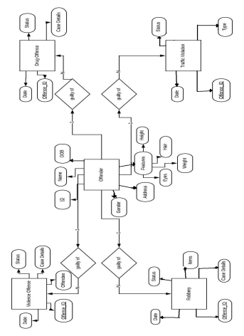

Fig 3.1 Entity Relationship Diagram

**Chapter 4**

# Detailed Design

The design describes the relation between various modules and functions of the system. Data flow diagrams (DFD) identify the main components that would be developed for the product and their interfaces. A DFD illustrates how a system or a software in terms of inputs and outputs processes data. As its name indicates, its focus is on the flow of information, where data comes from, where it goes and how it gets stored. There are different levels at which data flow diagrams can be shown. Each level is a magnification of the entities on the previous level and shows a more detailed description of the modules on the previous level. The data flow up to two levels has been illustrated in this section.

# 4.1 DFD Level 0

The level 0 DFD (Fig 4.1) shows the basic direction of data flow between the investigation team and the criminal record search system.

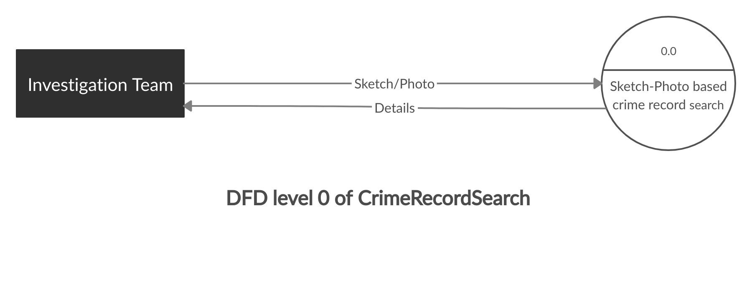

Fig 4.1 DFD Level 0

# 4.2 DFD Level 1

The level 1 DFD (Fig 4.2) shows the data flow between the major processes of the system which are sketch-photo conversion and criminal record search.

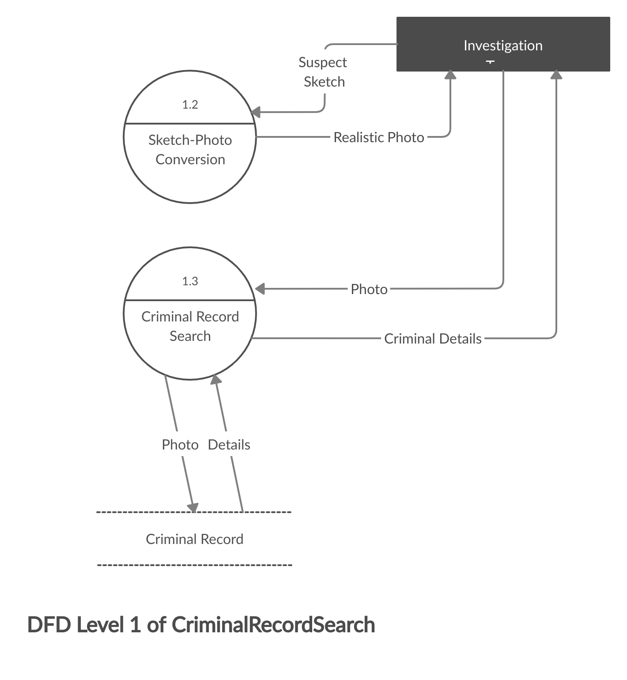

Fig 4.2 DFD Level 1

# 4.3 DFD Level 2 for Sketch-photo conversion

Sketch-photo synthesis is further broken down in the level 2 DFD (Fig 4.3). A model is obtained by training the neural network using the concept of generative adversarial networks(GANs) with a predefined face-dataset (CUHK). The trained model is compiled each time when a realistic photo needs to be produced when given a sketch.

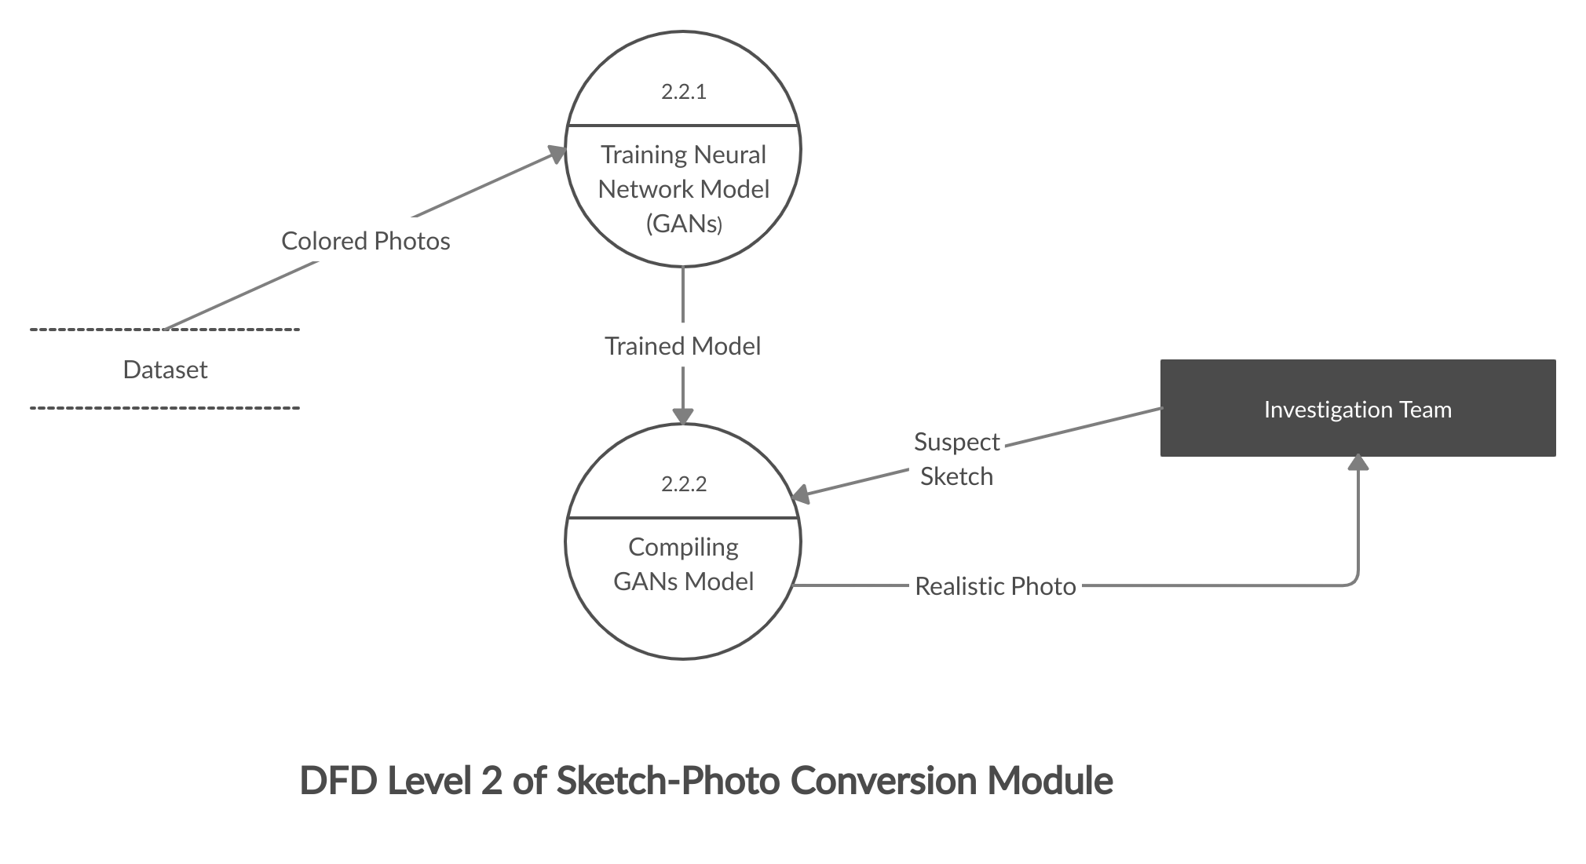

Fig 4.3 DFD Level 2 for sketch-photo conversion

# 4.4 DFD Level 2 for criminal record search

The criminal record searching process is divided in the level 2 DFD (Fig 4.4).

A realistic photo of the suspect is compared with the criminals in the criminal photo database (mugshot) by face-to-face matching process. If a match exists, retrieval of personal details and past crime records of the matched criminal is performed which is then used to generate a report.

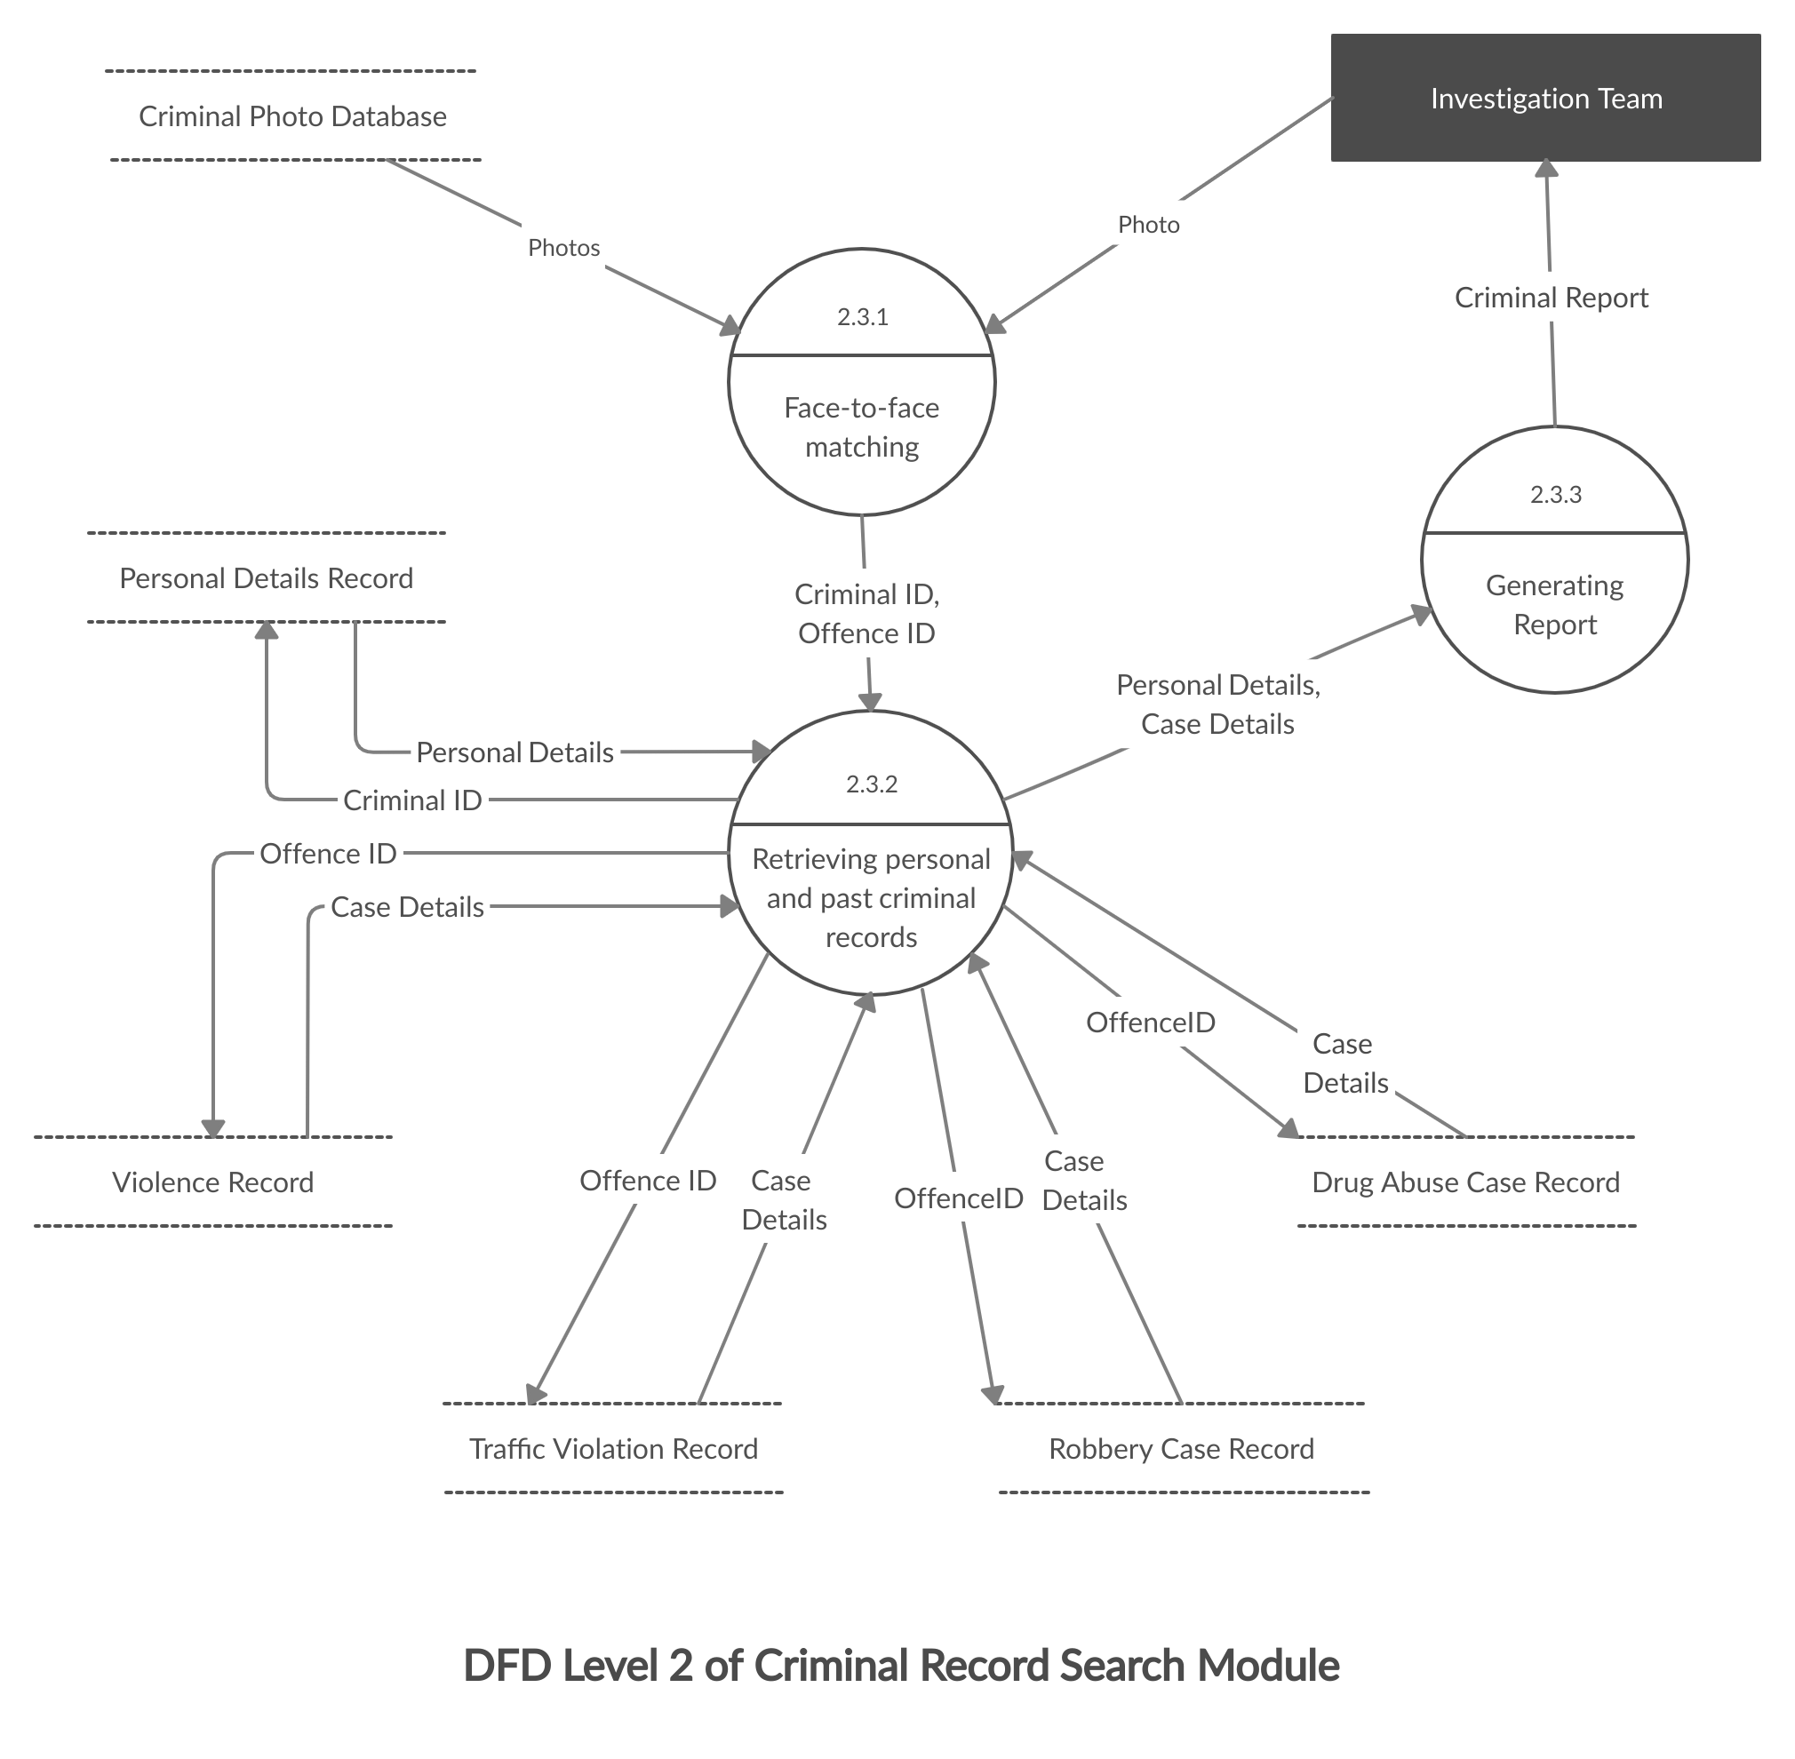

Fig 4.4 DFD Level 2 for criminal record search

**Chapter 5**

# Relational Schema and Normalization

From the ER diagram, relational schemas are obtained by mapping entities and relationships to tables as shown in Fig 5.1. It is important to normalize the tables before implementing the database system in order to achieve an optimal design of the tables. Normalization consists of applying a sequence of tests to the relational schema to certify whether it satisfies a certain normal form. It is performed using a top-down approach by applying the criteria for each successive normal form to each relation and decomposing the relations as required. During normalization each relational schema is analyzed based on functional dependencies, resulting in a relation schema with minimal redundancy.

Figures 5.2 through 5.4 show the relational schemas normalized to 1NF, 2NF and 3NF respectively. Fig 5.2. shows the relational schema in 1NF in which there are no multivalued attributes or composite relations. This schema is further normalized to 2NF in Fig 5.3. by ensuring that no non-prime attribute is partially dependent on any key of the schema. This schema is finally normalized to 3NF in Fig 5.4 by further ensuring that every non-prime attribute is fully functionally dependent and non-transitively dependent on every key.

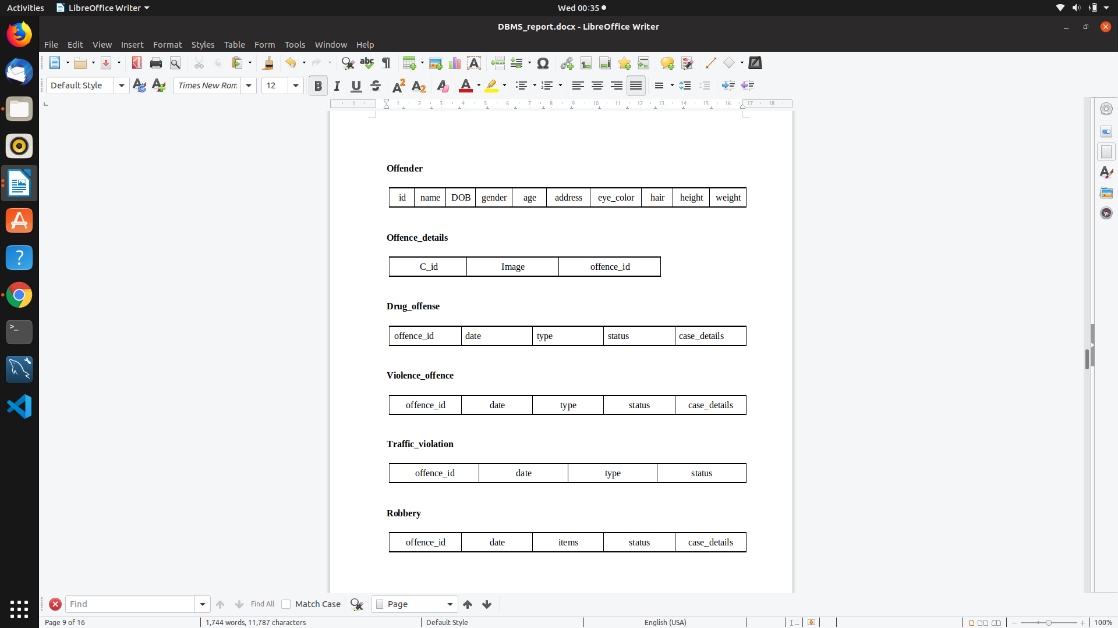

Fig 5.1 Database schema obtained from ER Diagram





**Offences**





Fig 5.2 Normalization to 1NF



**Address**

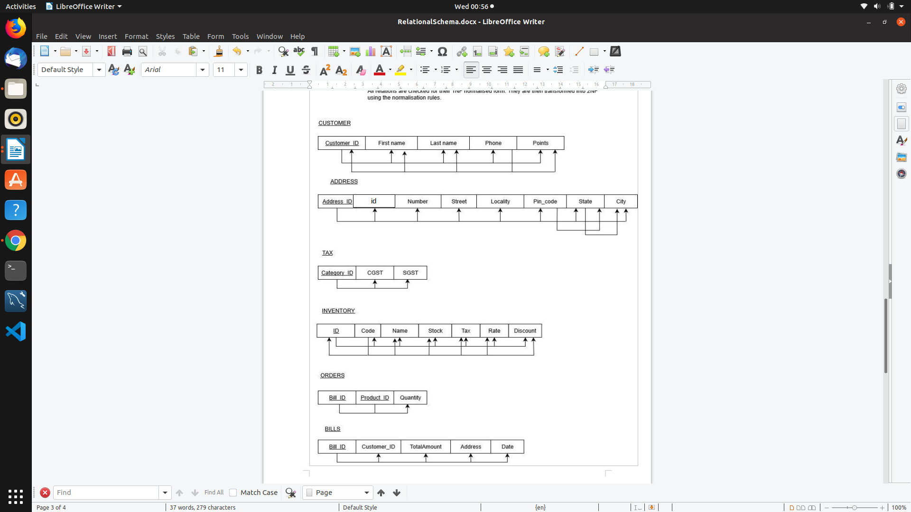



**Offences**





Fig 5.3 Normalization to 2NF



**Address**

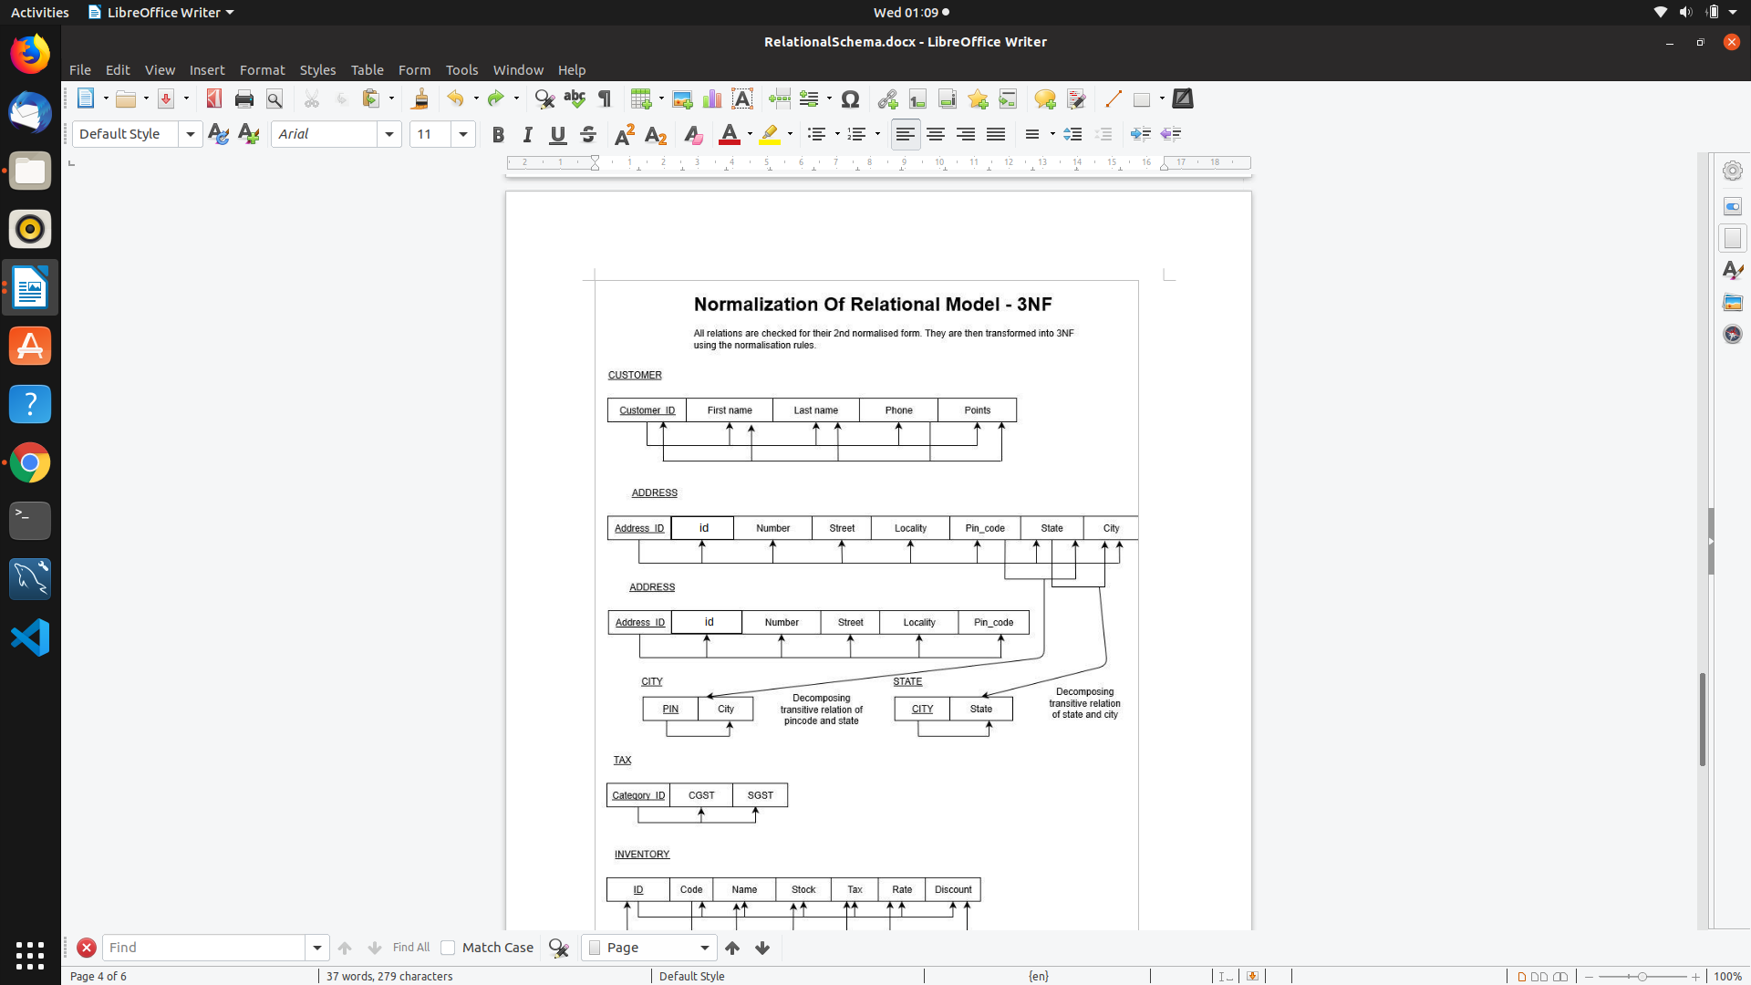



Offences





Fig 5.4 Normalization to 3NF

**Chapter 6**

# Integrating NoSQL to SQL Database

The application has a user interface where a sketch of potential suspect is fed.The sketch is analysed and compiled by the neural network model to obtain a realistic photo which is then run against mugshot database for a match. The SQL database contains case details of various types of crime such as robbery, violence against others, traffic_violation and drug_abuse. Further, personal information about the criminal is also present. The NoSQL database stores the photos of the criminal (mugshot) and the offence_id’s of the offences committed by the criminal. Fig 6.1 depicts the system architecture.

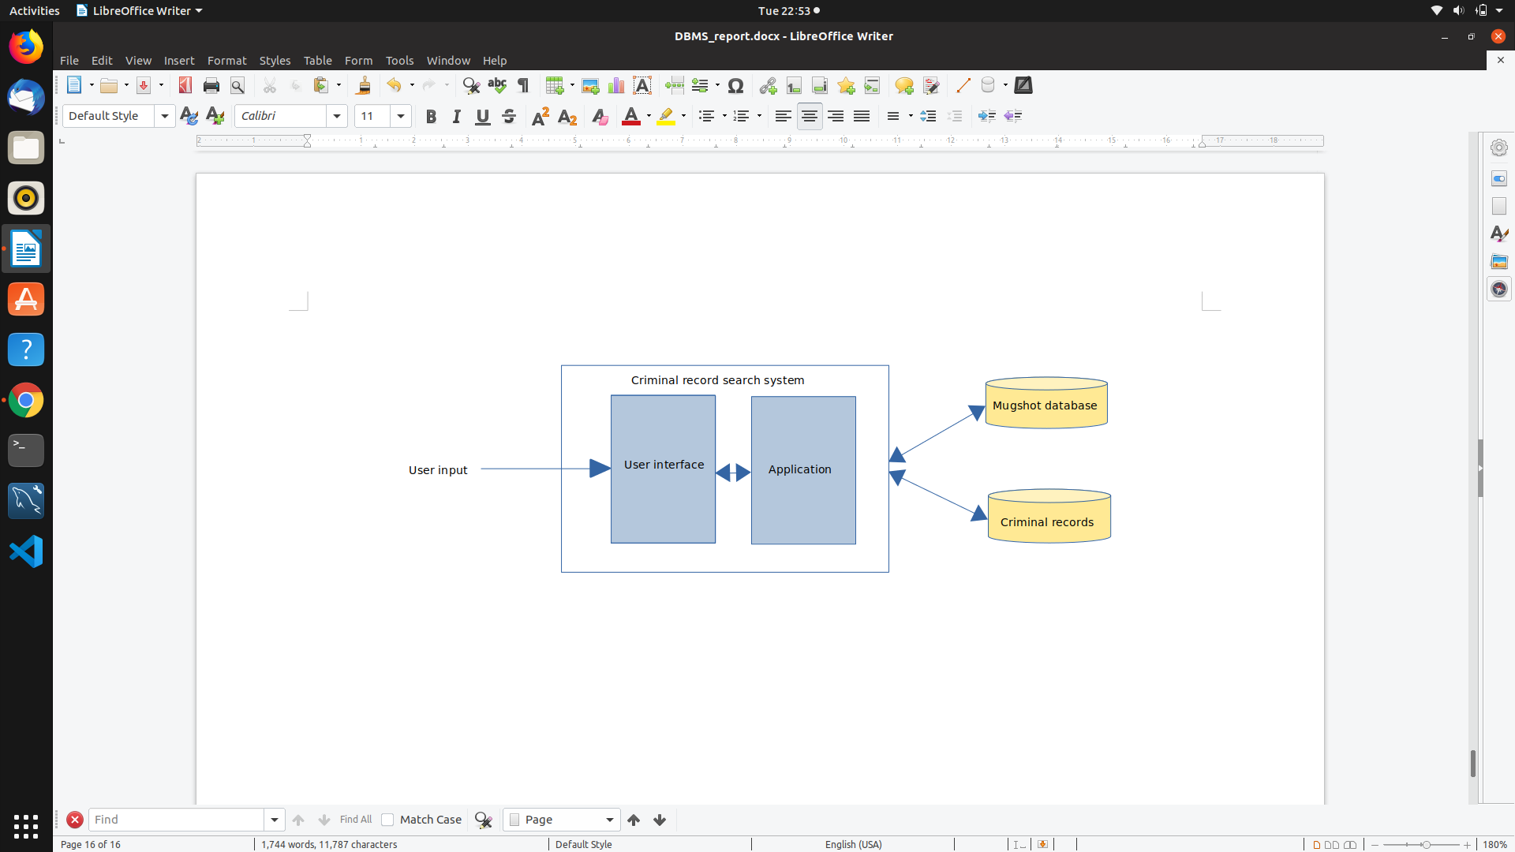

Fig 6.1 System architecture

**Chapter 7**

# Conclusion

Construction of the composite was originally performed by a trained artist, through drawing, sketching, or painting, in consultation with a witness or victim. Subsequently, techniques were devised for use by those less artistically skilled, employing interchangeable templates of separate facial features.The proposed system aids law enforcement agencies to speed up the process of identification of suspects and accuracy as they no longer rely on hand-drawn sketches.

# References

1. Jun Yu, “Towards Realistic Face Photo-Sketch Synthesis via Composition-Aided GANs”, 2018. Available: <https://arxiv.org/pdf/1712.00899.pdf>
2. Wengling Chen,James Hays,”SketchyGAN: Towards Diverse and Realistic Sketch to Image Synthesis,” Georgia Institute of Technology, 2018. Available: <http://openaccess.thecvf.com/content_cvpr_2018/papers/Chen_SketchyGAN_Towards_Diverse_CVPR_2018_paper.pdf>
3. Patsorn Sangkloy , Jingwan Lu, “Controlling Deep Image Synthesis with Sketch and Color,” Princeton University, 2016. Available: <https://arxiv.org/pdf/1612.00835.pdf>
4. Face recognition module - <https://face-recognition.readthedocs.io/en/latest/readme.html>
5. Face dataset - <http://mmlab.ie.cuhk.edu.hk/archive/facesketch.html>

# Appendix: Screenshots with descriptions

## 

Fig A.1 depicts a form where the sketch needs to be uploaded. The investigation team can upload a sketch of suspect through this form.

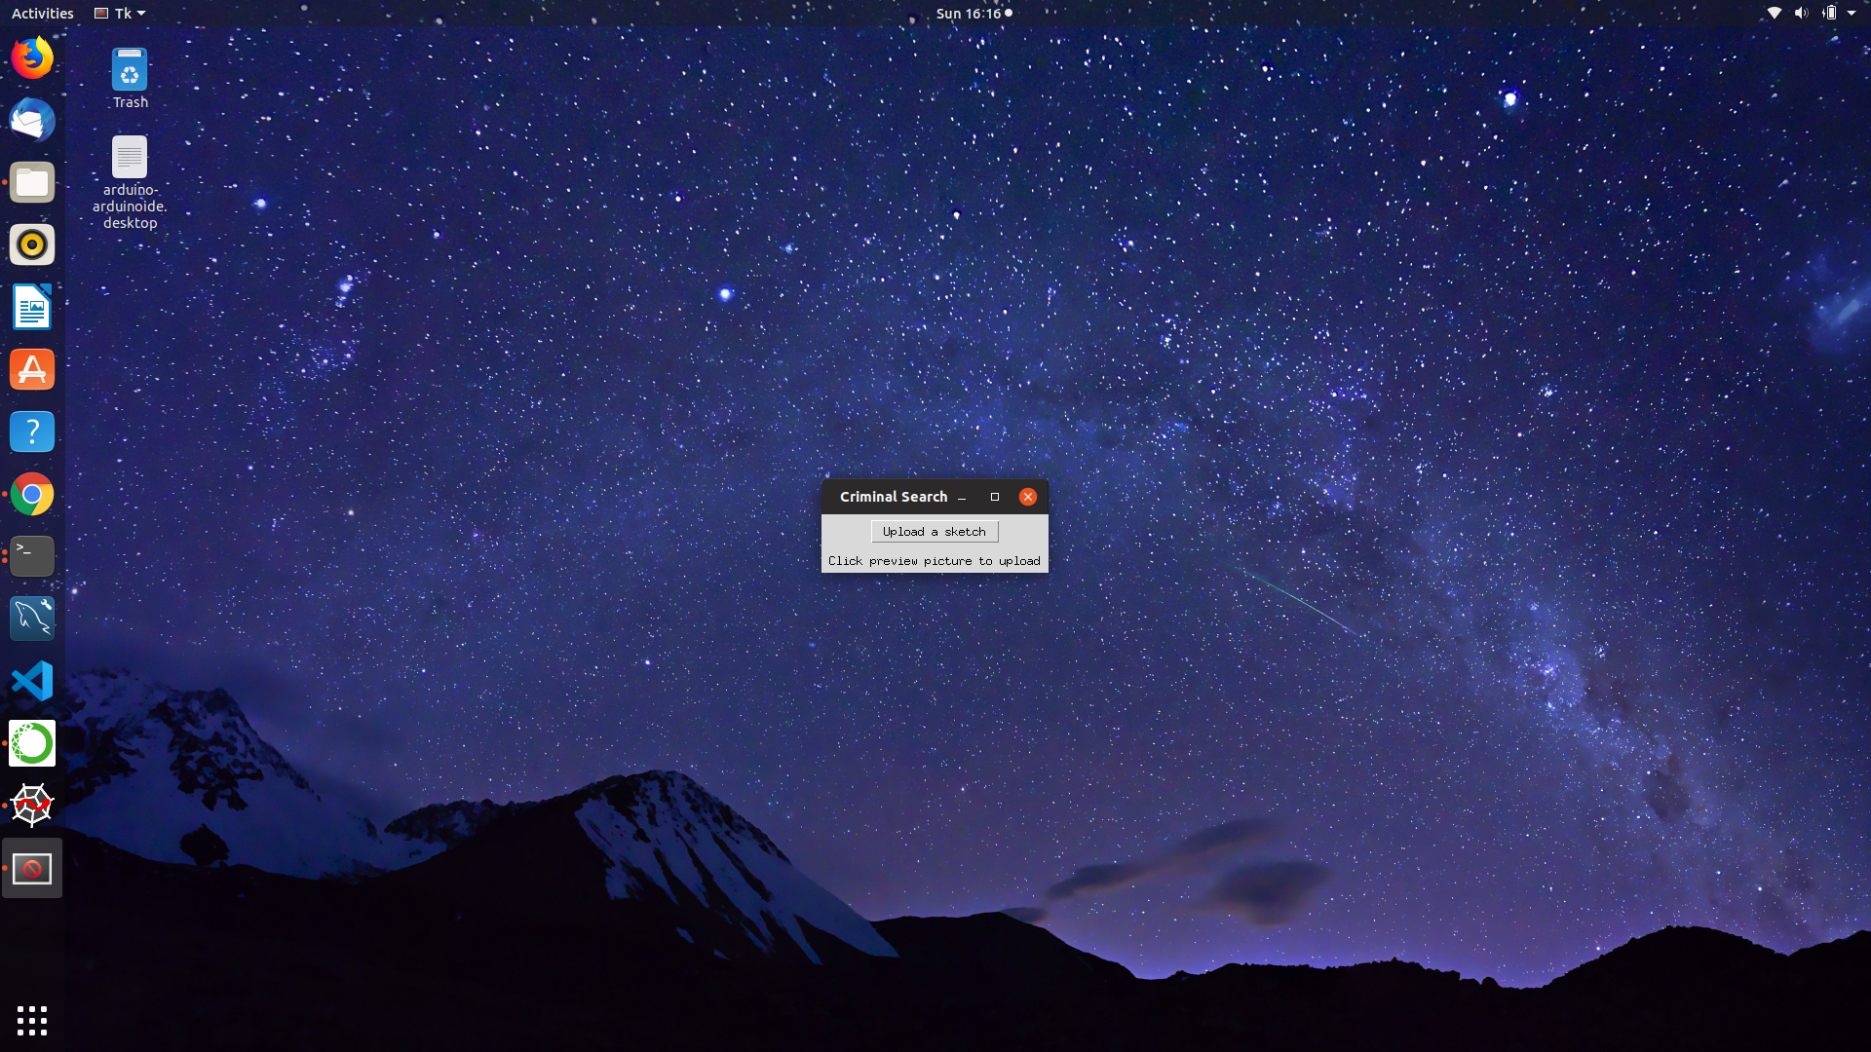

Fig A.1 Upload page

Fig A.2 shows preview of the sketch uploaded. The user can obtain a realistic photo by clicking the create photo button

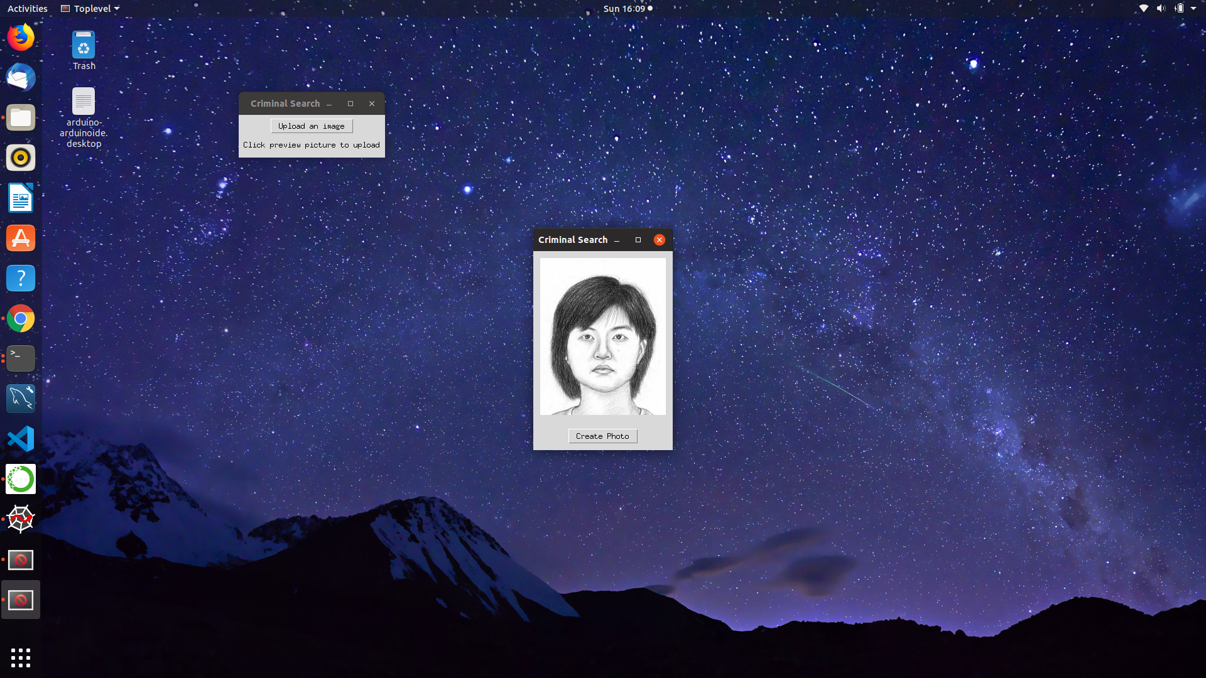

Fig A.2 Preview page

Fig A.3 shows the generated realistic image from the sketch uploaded.

User can make use of this photo to search against the mugshot database to identify the suspect.

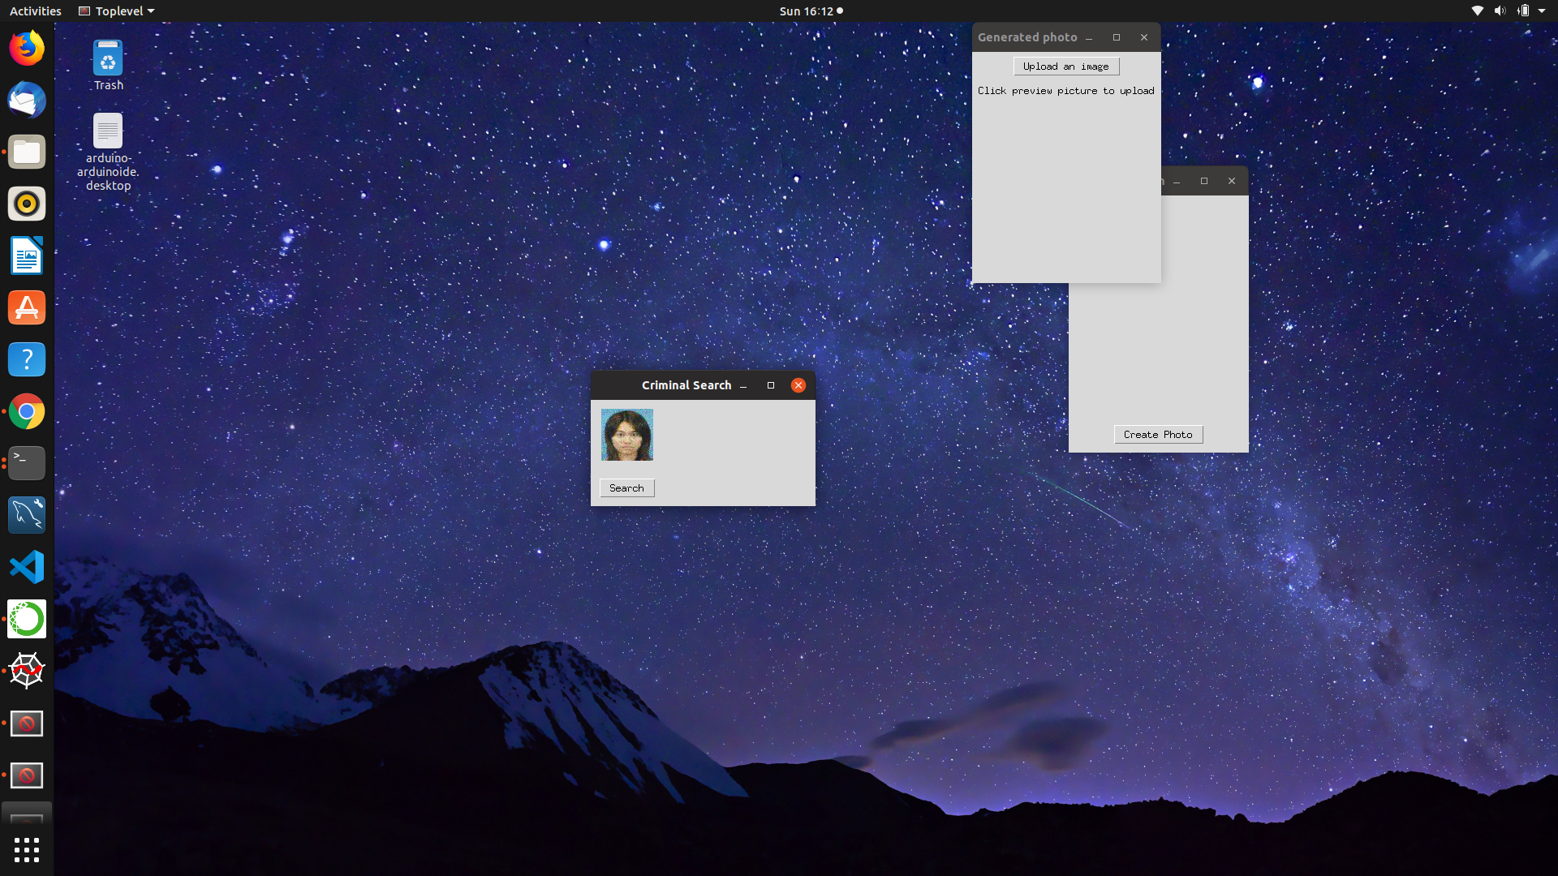

Fig A.3 Generated photo

Fig A.4 indicates that a match exists and the suspect is identified. User can obtain the personal details and criminal history of the suspect.

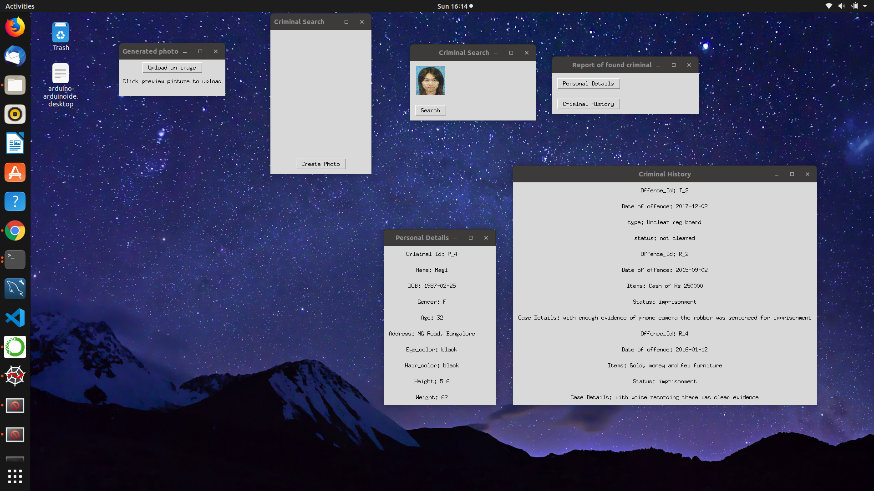

Fig A.4 Report of found criminal

Fig A.5 represents the personal information of the identified suspect

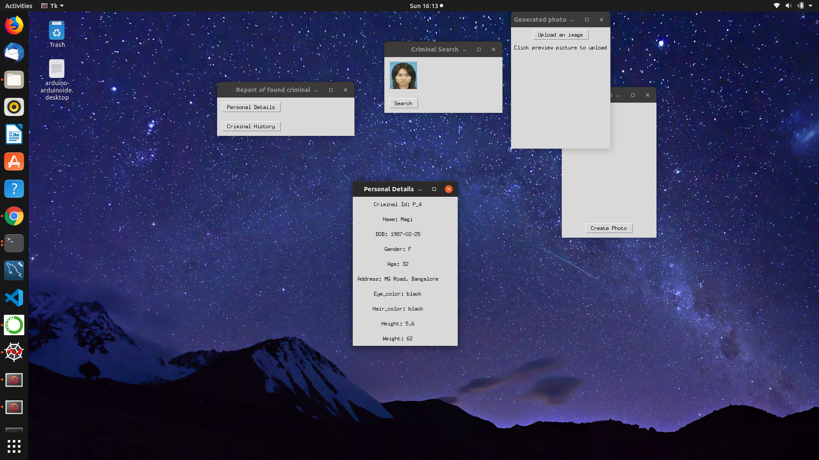

Fig A.5 Personal details report

Fig A.6 represents the criminal history of the identified suspect

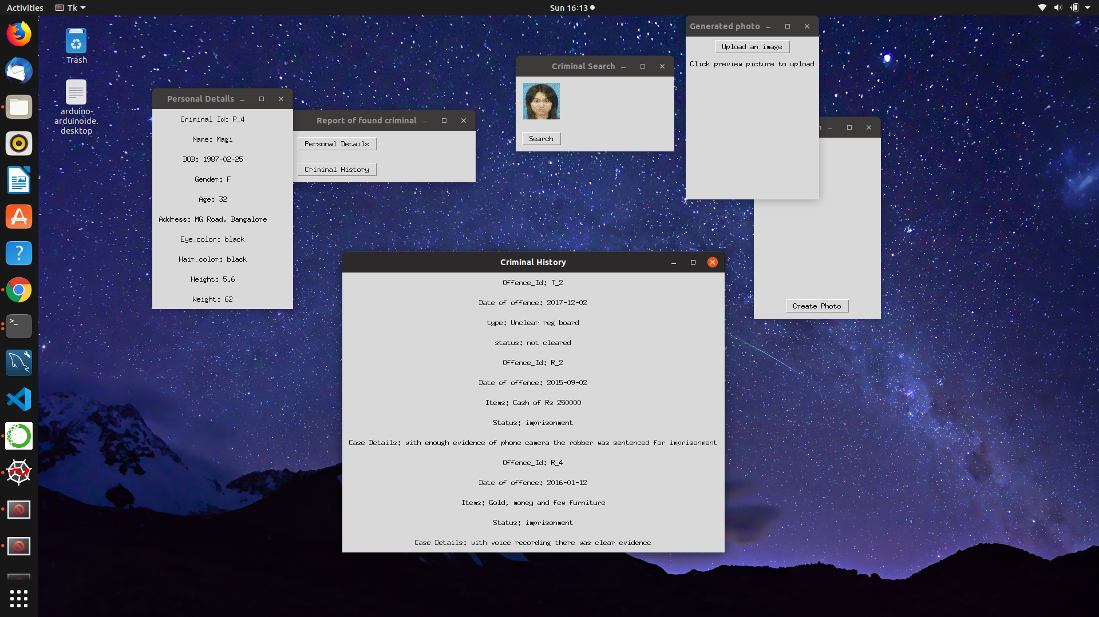

Fig A.6 Criminal history report

If the suspect has no past criminal records , a message of it not being found is displayed as in Fig A.7.

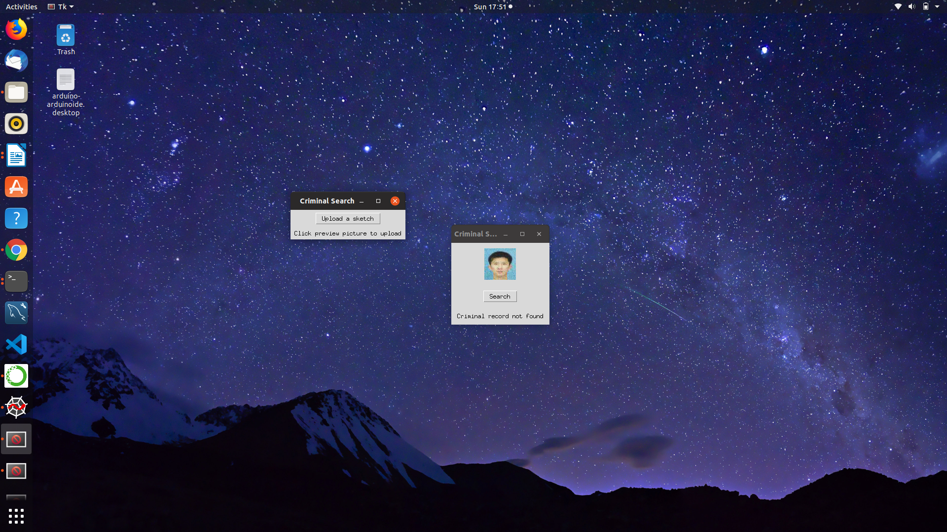

Fig A.7 Criminal record not found